Think of data as the 3 V’s: volume, velocity, variety, to choose how to ingest the data

Gsutil for uploading files

Storage Transfer Service: When the data is in a different cloud storage provider Or not enough bandwith

Transfer appliance: large quantities of data

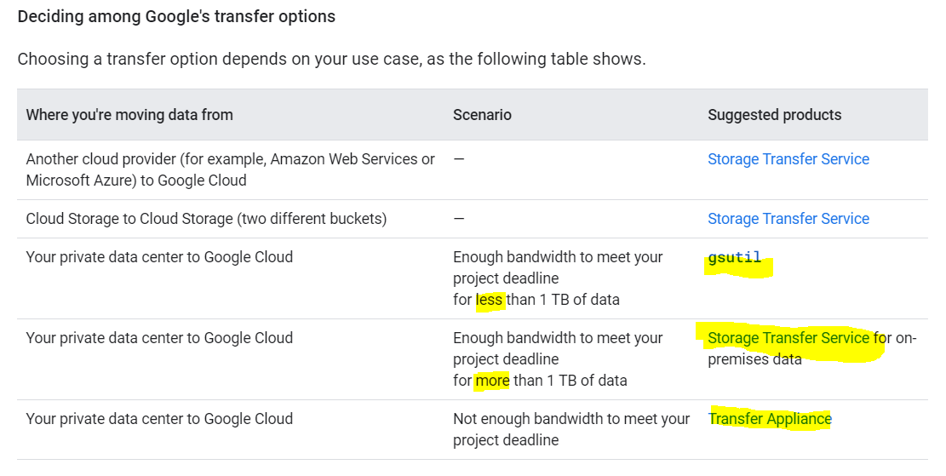

**Increasing network bandwidth:**

**When transfering from Cloud-To-Cloud:**

In a cloud-to-cloud transfer between Google Cloud and other cloud providers, Google provisions the connection between cloud vendor data centers, requiring no setup from you.

**Connecting with a public internet connection**

-Network throughput is less predictable because you're limited by your internet service provider's (ISP) capacity and routing.

- low cost

- Your data will go through the public internet + will go through some hops

**Connecting with Direct Peering (MORE PRIVATE):**

- Access the Google network with fewer network hops than with a public internet connection

- You can exchange internet traffic between your network and Google's Edge Points of Presence (PoPs), **which means your data does not use the public internet.**

**Connecting with Cloud Interconnect:**

-Cloud Interconnect offers a direct connection to Google Cloud through Google or one of the Cloud Interconnect service providers.

- This service helps prevent your data from going on the public internet

- It can provide a more consistent throughput for large data transfers.